学术报告会通知
题目：Boron Double-Chains and Fluxional Bonds in Boron Nanostructures
报告人：Prof.Si-Dian Li
（Institute of Molecular Science, Shanxi University）
时间：2018年8月10日14：30
地点：明故宫校区A9-402
主办单位：机械结构力学及控制国家重点实验室、校科协、航空宇航学院
报告内容简介：
The novel structural and bonding patterns of boron nanoclusters have attracted considerable attention in both chemistry and materials science in recent years. We present herein the latest combined experimental and theoretical investigations on cage-like borospherenes B_{n}^{q} (q=n-40, n=36-40), metal-doped heteroborospherenes Ni_{n}∈B₄₀ (n=1-6), planar borophenes (Fig.1), metal-doped Ni₂∈B₁₄ heteroborophenes, tubular molecular rotors B₂-Ta@B₁₈⁻, B₃-Ta@B₁₈, and B₄-Ta@B₁₈⁺, and the tubular to cage-like structural transition in metal-centered boron clusters at Ta@B₂₂⁻ with the coordination number of CN=22. These nanostructures are dominated by boron double chains (BDCs), in which planar B₁₉⁻, tubular Ta@B₂₀⁻, and cage-like B₃₉⁻ exhibit almost barrier-free structural fluctuations at room temperature due to the existence of fluxional bonds (FBs) in electron-deficient systems (Fig.2). ¹⁻⁶ Fluxional bonds exist in the region between two quasi-rotational components of the systems which rotate against each other. FBs as an extension of the classic localized bonds (2c-2e bonds) and delocalized bonds (mc-2e bonds, m≥3) in chemistry may have important applications in molecular dynamics, aromatic properties, catalysis mechanisms, and electronics materials. Boron-based nanostructures possess properties complementary to carbon nanostructures and may find wide applications in catalysis, energy-storage, and electronics materials.

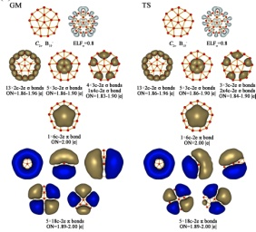
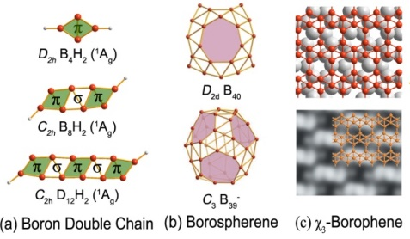
(a) AdNDP bonding patterns (b) flouxional σ-bonds in B₁₉⁻
Of C_{2v} GM and C_{2v} TS of B₁₉⁻ at 300 K.
Fig.1 Borospherenes and borophenes Fig.2 Heteroborospherenes and heteroborophenes
composed of interwoven boron double chains

报告人简介：
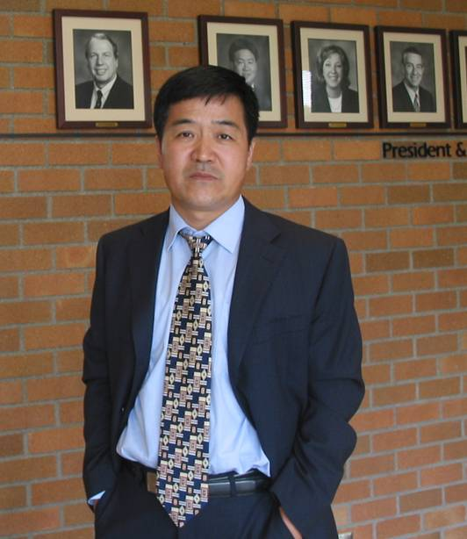
Si-Dian Li is a professor of chemistry in the Institute of Molecular Science at Shanxi University, P. R. China. He received his B.S. from Beijing Normal University in 1985, M.S. from Shanxi University in 1988, and Doctor of Engineering from Xi’an Jiaotong University in 2003. Before moving to Shanxi University in 2011, he served as the president of Xinzhou Teachers’ University from 2000 to 2011 and the president of Taiyuan Teachers’ College from 1996 to 2000.
Prof. Li has carried out joint researches at the University of Sussex in the UK, Pacific Northwest National Laboratory in the US, and Brown University. His fields of interests include theoretical and experimental research in structural chemistry, materials chemistry, and computational chemistry. His group in the past decade have been focusing on planar tetracoordinate carbons and silicons (J. Am. Chem. Soc., 2004, 2005; Angew Chem Int. Ed. 2004, 2005), boronyl (BO) chemistry (JACS, 2008; Acc. Chem. Res., 2014), all-boron fullerenes (borospherenes) (B₄₀^{-/0}: Nature Chemistry, 2014 and B₃₉⁻: ACS NANO, 2015), metalloborospherenes (Angew Chem Int. Ed. 2015, Nanosacle, 2018), heteroboronanotubes (Nanoscale, 2016, 2017; Chem. Comm.,2016), and monolayer (2D) heteroborophenes (JCP 2013, Sci. Reports, 2017) with over 140 papers published in various international journals in total. He and his group recently proposed the concept of fluxional bonds (FBs) as an extension the traditional localized bonds and delocalized bonds in chemistry.

